Shopify Tech Hype Cycle

# Technologies Used

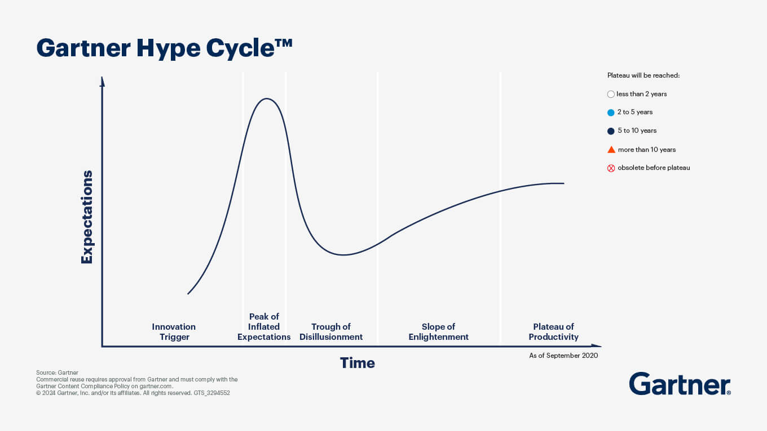

## 1. Innovation Trigger

**Supply Chain and Logistics:**

* **AI-Powered Demand Forecasting**: Shopify integrates with various AI tools to help merchants predict demand and manage inventory efficiently.

Hydrogen (React-based storefront framework)

Oxygen (Global hosting for Hydrogen)

Shopify Sidekick (AI assistant)

## 2. Peak of Inflated Expectations

React Native (for mobile apps)

AI for Image Editing (Shopify Magic)

## 3. Trough of Disillusionment

## 4. Slope of Enlightenment

React (frontend framework)

TypeScript (typed JavaScript)

Kubernetes (container orchestration)

Docker (containerization)

## 5. Plateau of Productivity

Ruby on Rails (backend framework)

MySQL (relational database)

| **Stage** | **Technology** | **Deep Details** | **Specific Brand Examples** |
| --- | --- | --- | --- |
| Innovation Trigger | Cloud-Based E-Commerce | SaaS scalability with headless API extensions. | Gymshark launching global e-commerce. |
|  | Blockchain Transparency | In Early adoption given the limited logistics partnerships. | Pangaia tracks sustainable materials. |
|  | Generative AI | Shopify Magic writes SEO-rich descriptions, saving smaller brands hours. | Broad application among Shopify users. |
| Peak of Inflated Expectations | Social Commerce | Shoppable posts via OAuth APIs on TikTok and Instagram. | Princess Polly targeting Gen Z. |
|  | AR | High-quality GLTF models for product try-ons (jewelry/sneakers). | Rebecca Minkoff for handbags. |
| Trough of Disillusionment |  |  |  |
|  | High Social Media Ad Costs | 47% rise in CPMs; brands pivoted to SEO and retention strategies. | Broad impact across SMB Shopify users. |
|  | Dropshipping Challenges | Long delivery times exposed weak logistics pipelines. | Niche sellers abandoning Oberlo. |
| Slope of Enlightenment | AI Personalization | Dynamic storefront adjustments for higher AOV. | Mid-tier brands achieving 30% upsell improvements. |
|  | Logistics Automation | AI-backed order routing ensures faster fulfillment (2-day guarantees). | Shopify Fulfillment Network for fast fashion. |
|  | AR 2.0 | Affordable virtual try-ons enhance the fabric flow experience. | More adoption by mid-tier fashion brands. |
| Plateau of Productivity | RFID and IoT | RFID-driven inventory tracking eliminates manual counts; IoT restocks items. | Zara optimizing in-store and warehouse operations. |
|  |  |  |  |
|  | Omnichannel Retail | Unified POS syncs analytics for online and offline channels. | Allbirds integrating pop-up and online inventory seamlessly. |

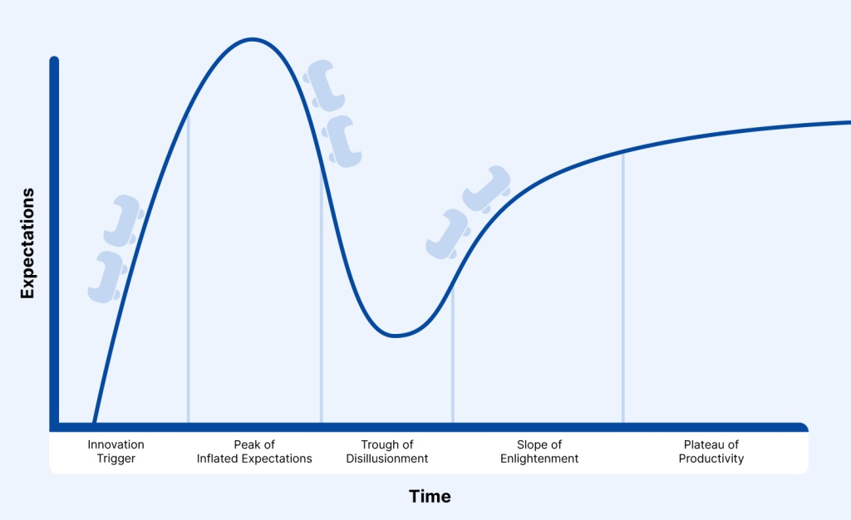

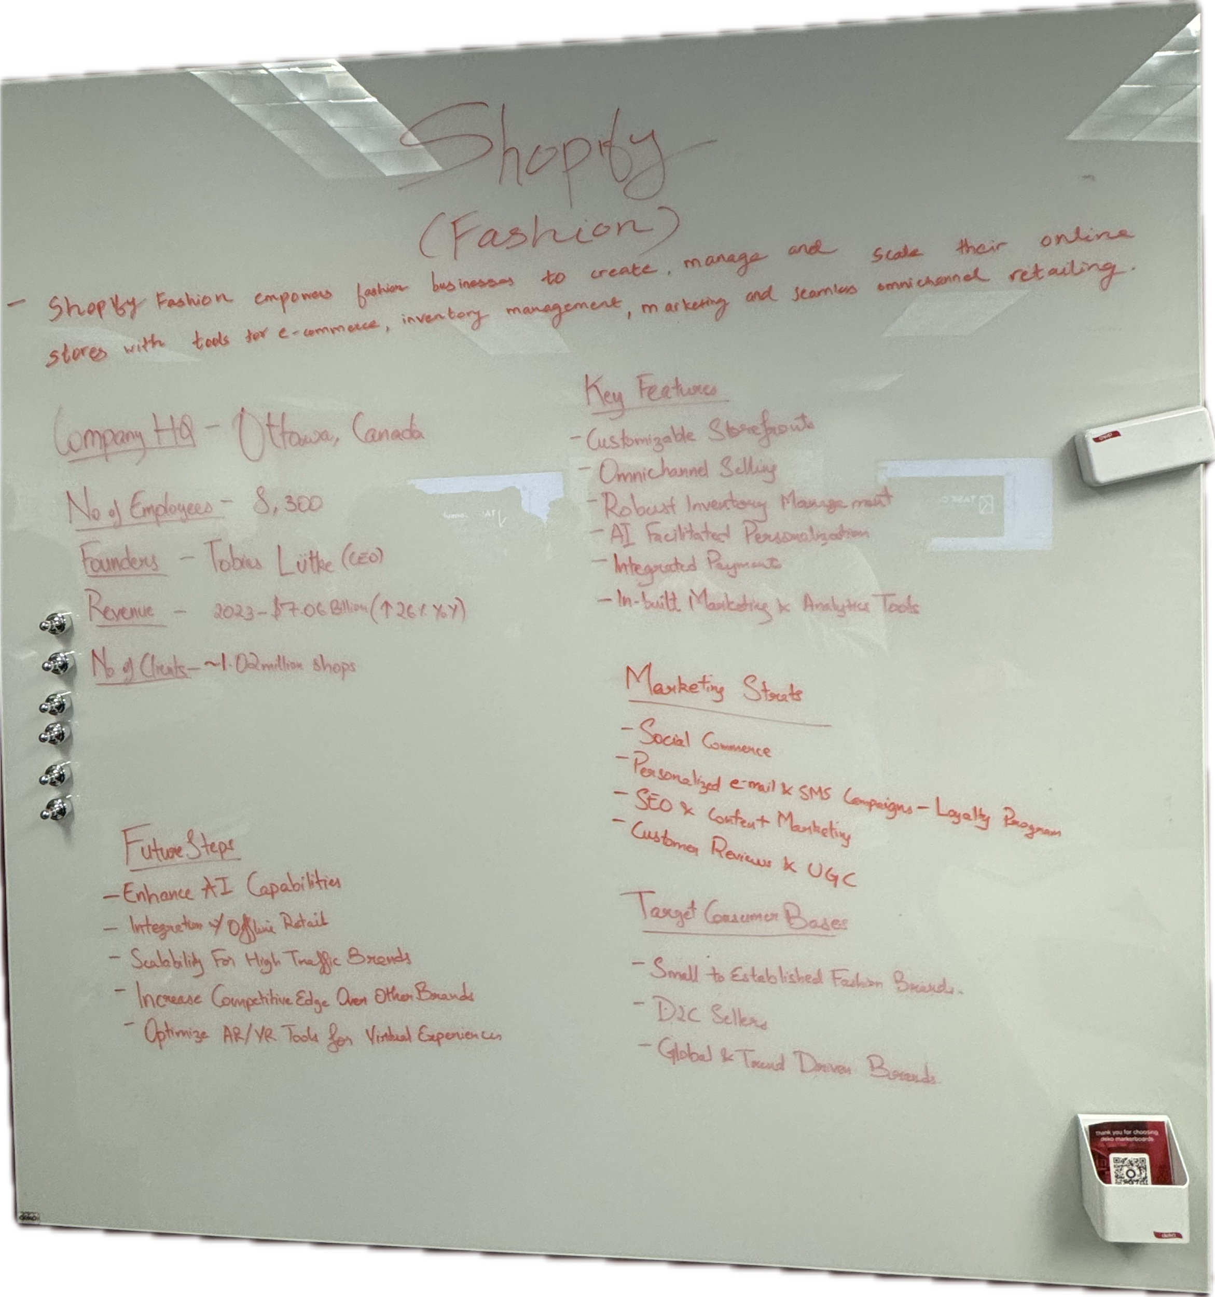

Red Ocean (Highly Competitive Markets)

1. Competing with Amazon in Fast Fashion Marketplaces

• Challenge: Amazon dominates online fashion retail with fast shipping and aggressive pricing.

• Recommendation: Shopify should differentiate with exclusive fast fashion partnerships (e.g., capsule collections with direct-to-consumer brands) and offer superior merchant branding tools to prevent commoditization of fashion products.

2. Enhancing Shopify’s Fulfillment for Fast Fashion

• Challenge: Fast fashion demands rapid logistics, but Shopify’s Shopify Fulfillment Network (SFN) is still growing.

• Recommendation: Shopify should optimize just-in-time fulfillment for fast fashion merchants by partnering with regional logistics hubs and offering AI-powered inventory predictions.

3. Improving the Shop App for Fashion Discovery

• Challenge: Consumers seek curated, trend-driven shopping experiences rather than a generic marketplace.

• Recommendation: The Shop App should prioritize fashion-first discovery, featuring influencer collaborations, AI-powered styling recommendations, and limited-time trend drops from Shopify merchants.

Blue Ocean (New Growth Opportunities)

1. Sustainable Fast Fashion Platform

• Opportunity: Consumers increasingly demand sustainable fashion, but many brands struggle to implement it.

• Recommendation: Shopify should create a “Sustainable Shopify” initiative for fast fashion merchants, offering:

• Verified eco-friendly supply chain solutions

• Integrated resale and upcycling marketplaces

• Carbon-neutral shipping options

2. Live Shopping & Social Commerce for Fashion

• Opportunity: Fast fashion thrives on real-time trends and influencer marketing.

• Recommendation: Shopify should integrate TikTok, Instagram Live, and YouTube Shopping directly into storefronts, allowing merchants to host live fashion drops and enable instant purchases via social media.

3. AI-Powered Personalized Fashion

• Opportunity: Consumers expect highly personalized fashion recommendations.

• Recommendation: Shopify should launch an AI-driven fashion styling engine where users input preferences, and Shopify merchants provide curated outfit recommendations.

4. Expanding into Emerging Markets with Local Fast Fashion Brands

• Opportunity: Latin America, Africa, and Southeast Asia have growing fashion markets but lack robust e-commerce infrastructure.

• Recommendation: Shopify should offer localized Shopify Fast Fashion platforms with tailored payment options (e.g., Buy Now, Pay Later), regional manufacturing connections, and influencer partnerships.

https://www.adweek.com/commerce/shopify-expands-ad-tool/